Currently Big Mountain Resort is charging **$81.00** for a ticket to ride. This price is based on taking the average price of similar resorts **(~$64.28)** and adding a surcharge of **$16.72**. While this solution has been working, we are looking to increase profitability in order to offset an addition of **$1.54 Million** to this season’s operating budget.

Through analyzing features of other parks, we have discovered several available options in order to achieve this goal.

Below is a heatmap that shows the correlation that features have to each other.

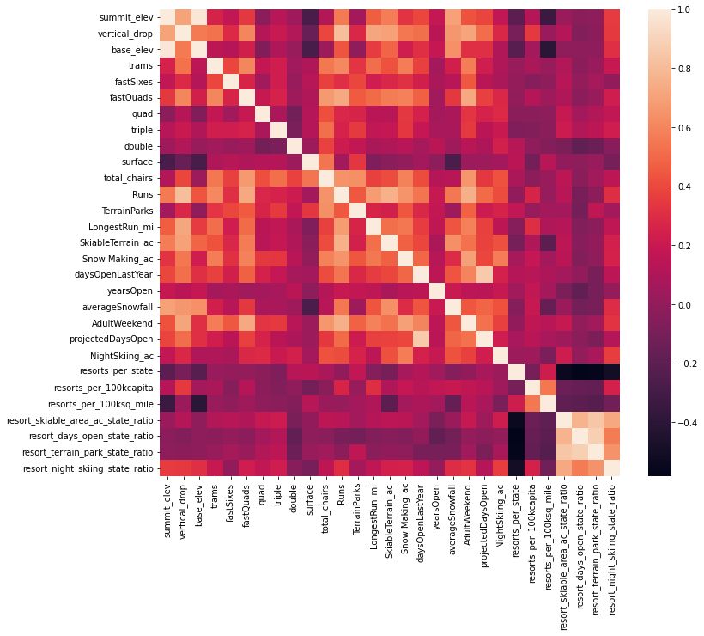

From this heatmap, a few points stand out as especially correlated to the price of an adult weekend ticket. The ones that we are mainly focusing on are: **vertical drop, fast quads, runs, and snowmaking acreage.**

Here are some graphs showing where Big Mountain lines up on these features compared to the other resorts in our market share:

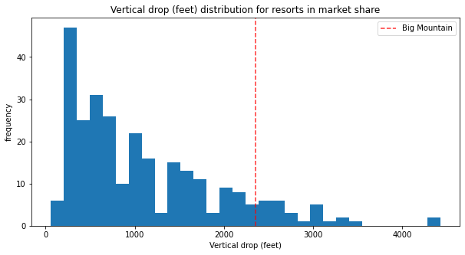

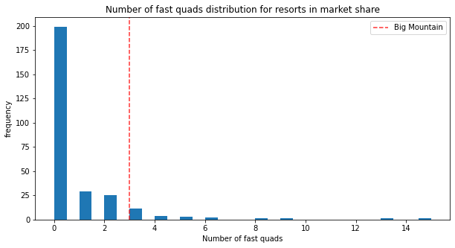

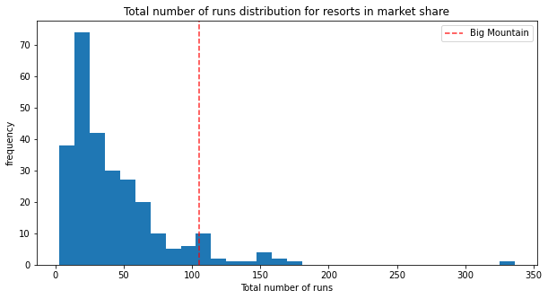

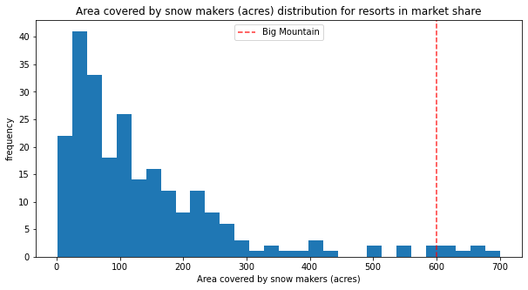

As can be seen, Big Mountain is **significantly** higher than the average resort in all of these categories.

Using this information, we were able to model what price Big Mountain could charge per ticket, as well as how much we could increase the price of a ticket by depending on potential changes.

Given the current features of the park, the modeled price per ticket goes from **$81.00** to **$95.87.** This **$14.87** increase in price would not only cover the $1.54 Million increase in the budget, but would increase profits by a remarkable **$26.02 Million** (assuming 350,000 guests buy 5 tickets each as is currently expected.)

Because of this, no additional changes are necessary currently, but as previously mentioned we did model some potential changes.

One example would be to increase the vertical drop of our current hill by 150 feet. Doing so would also require an additional lift. This change would support an increase in ticket price of an additional **$8.61** and would amount to an over **$15 Million** increase per season.

My recommendation would be to increase the ticket price to the modeled price without doing any current additions. This way we are able to increase profitability without increasing our budget, as well as allow for us to fully test how people would respond to this price increase. Given how large the increase in profits is, we could even offer discounts and promotions to guests who stay more days and still expect to be more profitable than before.